**Automatic Washing Machine using Microchip PIC18F Series Microcontroller**

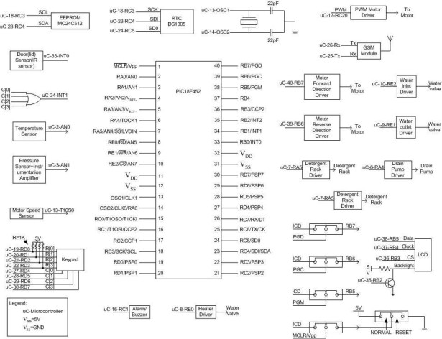

The design uses the PIC18F series microcontroller. All the control functionalities of the system are built around this. Upgradeability is the unique feature of this system. Control card hardware and software allows the manufacturer to add or remove the features as per customer requirement and model. Thus once the whole system is designed it is very economic in large quantity production. Single-phase motor is considered for the design. Front panel consists of a keypad and LCD display. Keypad provides automatic and manual wash options to the user. LCD display is convenient to convey machine information to user. One more design possibility is to use brushless DC motors or three phase induction motor. These types of motors are very efficient but requires complex control algorithm. To implement such a complex and real time algorithm dedicated controller and software is required which a master controller controls. Even though cost is important criteria modern washing machines are designed with BLDC motors owing to efficiency and energy conservation. But in this assignment single phase universal motor has been used to design prototype due to its simplicity.

1. The system should provide fully automatic mode, semi-automatic mode and manual mode. Modes should be selectable by a keypad. In semi-automatic mode also user requirement should be nil. But user has to choose any one of the semi-automatic mode in which washing conditions are predefined. Once the predefined mode is started the system should perform its job and after completion it should inform the userIn manual mode continuous intervention of user is required. User has to specify which operation he wants to do and has to provide related information to the control system. For example, if user wants to wash only, he has to choose ‘wash’ option in manual mode. Then the system should ask the user to enter the wash time, amount of water and the load. After these data are entered, the user should start the machine. When the specified operation is completed system should inform the user. The system should provide easy options for upgradeability of new features. The hardware and the software should be compatible to both machines, which have fewer features, or more features. Removal of any feature should not affect the working of any other features or overall working of the system.